# PortalGun

# *****All resources used were originally found at:

# <https://www.thingiverse.com/thing:1100601> and from there the following link -

# <https://github.com/pomeroyb/PortalGun>

# I have altered the pin-outs as necessary to allow for more sounds and for better organization of the wiring*****

Code to control a Portal Gun (From Rick and Morty)

##Libraries Download and install the following libraries:

* [ClickEncoder](https://github.com/0xPIT/encoder)
* [Adafruit_GFX](https://github.com/adafruit/Adafruit-GFX-Library)
* [Adafruit_LEDBackpack](https://github.com/adafruit/Adafruit-LED-Backpack-Library)

## Pin Definitions

If you deviate from the following definitions, you will have to change the firmware to account for that.

| **LED Display** | **Trinket Pro Pin** |
| --- | --- |
| SCL | A5 |
| SDA | A4 |
| GND | GND |
| Vcc | 5V |
| Vi2c | 5V |

| **Rotary Encoder** | **Trinket Pro Pin** |
| --- | --- |
| A | A1 |
| B | A0 |
| GND | GND |
| Button | A2 |

| **LED** | **Trinket Pro Pin** |
| --- | --- |
| Top Bulb | 13 |
| Front Right | 12 |
| Front Center | 11 |
| Front Left | 10 |

## Installing Firmware

First, [set up the Arduino IDE according to Adafruit](https://learn.adafruit.com/introducing-pro-trinket/setting-up-arduino-ide). Connect your Trinket Pro and make sure the bootloader is running, then click upload.

## Button Behavior

The rotary encoder has a click button, and we can detect a single click, a double click, and a hold.

* Single Click : Wakes the Trinket Pro from low power mode
* Double Click : Reset to dimension C137
* Hold : Turn off LEDs and put the Trinket Pro into a low power mode.

## Sound FX Pin Definitions

If you deviate from the following definitions, you will have to change the firmware to account for that.

| **FX Sound Board** | **Trinket Pro Pin** | | **Sound Effect Dimension Location**  For these locations you can use any sound file you want, I used VLC media files (.OGG) per the specifications by Adafruit |
| --- | --- | --- | --- |
| 0 | | 0 | C136 – this is the value entered on the LED display |
| 1 | | 1 | C135 |
| 2 | | 2 | C134 |
| 3 | | 3 | C133 |
| 4 | | 4 | C132 |
| 5 | | 5 | C131 |
| 6 | | 6 | C130 |
| 7 | | 7 | C129 |
| 8 | | 8 | C128 |
| 9 | | 9 | C127 |

The above listing of the pin connections between the Pro Trinket and the Sound Board is just for the sake of clarity. The small size of the main body of the Portal Gun imposed severe restrictions on the layout of the components. It was necessary to lay the boards next to each other, which allowed very few options for connections. The use of solid core wire, which by its nature is very stiff, further complicated the assembly process. So there are only six sound files in use, and the actual layout and pin connections are illustrated below.

**Pro Trinket Sound Board**

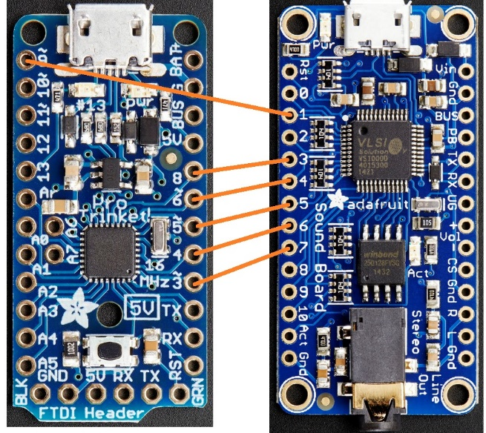

Wiring all of the components for this project proved to be quite a challenge.

The difficulties in assembling the circuit will probably be greatly reduced by soldering everything to a PCB instead of using wire.

## Installing Firmware

First, [set up the Arduino IDE according to Adafruit](https://learn.adafruit.com/introducing-pro-trinket/setting-up-arduino-ide). Connect your Trinket Pro and make sure the bootloader is running, then click upload.

##Installing SFX You should be able to just connect the FX board to the computer, and drop the files in the "sfx" folder onto it. The files do follow a naming convention ([see here](https://learn.adafruit.com/adafruit-audio-fx-sound-board/triggering-audio)), so don't change the file names unless you know what you're doing.